**SE3330 Course Project Iteration Planning Record**

**Iteration**: 1

**Team name**: NullRefrenceException

**Team Leader**: Mitch Vance

**Date**: 02/22/2019

1. **Sprint Backlog:**

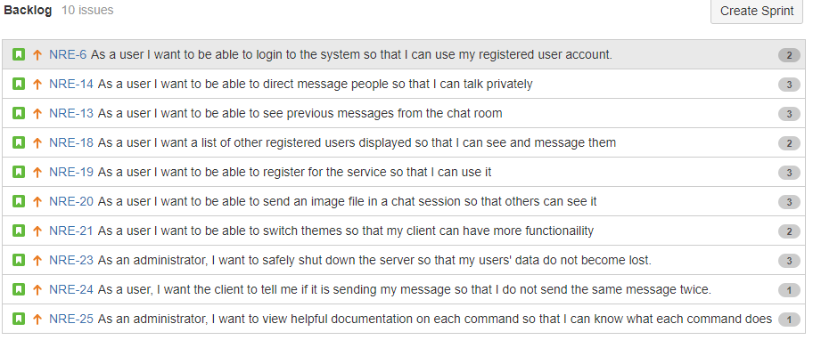

1. **Task breakdown:**

|  |  |  |  |
| --- | --- | --- | --- |
| **Story ID** | **Tasks** | **Assigned to** | **Estimated Time** |
| **NRE-5** | Message validation **[NRE-26]** | Austin FitzGerald | 1 |
| Send the message to the server **[NRE-28]** | Mitch Vance | 2 |
| Testing **[NRE-32]** | Austin and Mitch | 2 |
| **NRE-10** | Server should append metadata to message **[NRE-34]** | Ryan Wolff | 1 |
| Client should display messages with metadata **[NRE-35]** | Austin FitzGerald | 2 |
| Testing **[NRE-36]** | Ryan and Austin | 2 |
| **NRE-22** | Practice observer pattern **[NRE-37]** | Liam Crain and Mitch | 3 |
| Testing **[NRE-38]** | Liam Crain and Mitch | 1 |
| **NRE-29** | Popup connection window **[NRE-30]** | Liam Crain | 2 |
| Server listens for new connections **[NRE-31]** | Ryan Wolff | 1 |
| Testing **[NRE-33]** | Liam and Ryan | 2 |

1. **Individual Assignment Summary**

|  |  |  |
| --- | --- | --- |
| **Team Member** | **Assigned Tasks (ID)** | **Total estimated time** |
| Mitch Vance | [NRE-28], [NRE-32], [NRE-37], [NRE-38] | 6 |
| Ryan Wolff | [NRE-30], [NRE-33], [NRE-34], [RE-36] | 6 |
| Austin FitzGerald | [NRE-35], [NRE-26], [NRE-32], [NRE-36] | 7 |
| Liam Crain | [NRE-31], [NRE-33], [NRE-37], [NRE-38] | 8 |